Haptic feedback Walking Stick for the blind

Group K Information: 1

Introduction 1

1.1 Brief Description of the Product 2

1.2 Evolution from the Original Idea Presented in Part 1 2

Competitive Analysis 3

2.1 Analysis of Existing Solutions 3

2.2 Advantages and Disadvantages of Available Solutions 5

User Requirements 10

3.1 6-10 User Requirements 10

3.2 Explanation of How These Requirements Were Derived 10

Approach to Addressing Requirements 14

4.1 Brief Explanation of Strategies to Meet User Requirements 14

Conclusion 15

Bibliography and References 15

Appendices 15

# Group K Information:

Group Names:

* Mohamed Ahmed Abdalla
* Abdisalaam Dahir
* Ilyaas Osman
* Sadde Aden
* Tomi Akinyemi
* Faysal mohamed

# Introduction

## 1.1 Brief Description of the Product

Our GuidancePro stick concept is a haptic feedback walking stick enhancing the commuting experience for the visually impaired. It focuses on interaction design, incorporating tactile or audio feedback to alert users of obstacles, give directions, and update the user on their location.



## 1.2 Evolution from the Original Idea Presented in Part 1

**Original Concept:**

The initial idea focused on developing a mobile application equipped with features catering to the needs of blind or visually impaired commuters.

Evolution to the **"GuidancePro Stick" System concept:**

* Continuation of Mobile App: Maintaining the development of a supportive app for enhanced functionality.
* Introduction of "GuidancePro Stick": Development of a tactile walking stick with advanced features.
* Integration with App: Ensuring seamless connectivity between the stick and the mobile application.
* Combined Haptic and Audio Feedback: Creating both the stick's tactile feedback and app's audio guidance for navigation.
* Real-Time Information Access: Providing updated transit information through the app which is accessible via the stick.
* Holistic Commuting Solution: Combining the physical aid of the stick with the digital assistance of the app.

# Competitive Analysis

## 2.1 Analysis of Existing Solutions

1. **Lazarillo**

Through increased mobility, the Lazarillo app facilitates navigation for people with visual impairments. The app's audio capabilities, which alert users to their current location, nearby points of interest, and crosswalks, are very useful when in exploration mode for users who are walking, driving, or taking public transit. The software makes it simpler to locate nearby companies and services, including banks, eateries, shops, and medical facilities, with its category search option. You can use voice and keyboard input to arrange journeys to your target locations.

Users can customize the navigation experience and increase efficiency by marking and saving their favorite sites for quick access in the future. Users can adjust the voice engine, language, layout, and measurement units for announcements to suit their preferences thanks to the app's high degree of customization capabilities. Furthermore, Lazarillo offers wayfinding audio advice, giving users access to up-to-date auditory information to support safe indoor and outdoor navigation.

2. **TapTapSee**

TapTapSee emerges as a mobile application specifically crafted to assist individuals with visual impairments by harnessing the capabilities of a device's camera. This versatile application is compatible with both iOS and Android devices, delivering a comprehensive array of features aimed at augmenting the user's awareness of their surroundings.

**Key Features and User Interaction:** At the heart of TapTapSee's functionality lies its proficiency in object recognition, utilizing the device's camera to capture images and subsequently delivering audible descriptions of the identified objects to users. The application further highlights its text recognition capabilities, empowering users to have printed information read aloud. The seamless integration of voice guidance aids users in capturing clear images by providing real-time feedback. The inclusion of a user community through forums cultivates a sense of support and collaboration, enabling individuals to share experiences and seek advice. TapTapSee prioritizes a user-centric design, offering customization options for voice preferences and language to ensure a personalized experience. The user interface is designed for simplicity, featuring large buttons to enhance usability for visually impaired individuals.

**Strengths and Community Engagement:** TapTapSee excels in real-time object recognition, allowing users to swiftly and efficiently identify objects in their environment. The incorporation of a user community introduces a social dimension, enriching engagement by facilitating the exchange of tips and experiences among users.

**Weaknesses** and **Functional Limitations:** While TapTapSee demonstrates proficiency in object recognition, it may present limitations in offering extensive navigation features and wayfinding capabilities. Additionally, the application's reliance on the device's camera could pose challenges in low-light or no-light conditions, potentially impacting its functionality during such scenarios.

**Conclusion and User-Centric Focus:** TapTapSee's strength lies in its dedicated focus on real-time object and text recognition, contributing to a more informed experience for visually impaired users. The emphasis on community engagement aligns seamlessly with its user-centric approach, fostering a supportive environment within the application. Despite potential limitations in navigation features and low-light scenarios, TapTapSee emerges as a valuable tool, enhancing the perceptual experiences of visually impaired individuals across diverse contexts.

3. **Seeing AI**

Seeing AI is an app developed by Microsoft designed to help individuals with visual impairments. It helps them navigate the world around them more independently by being able to read printed text aloud, which is useful for tasks like reading signs, labels, or documents.

4. **Be My Eyes**

For those who are blind or visually impaired, Be My Eyes is an essential software that was created with inclusivity and support in mind. Through live video conversations, the app pairs users with sighted volunteers to enable visually impaired people to get real-time assistance with a variety of daily tasks. Be My Eyes uses technology to build a worldwide community that is not limited by geographical distance, while still embodying the spirit of generosity in human nature.

5. **Blind Square**

Blind square is a navigation app which offers detailed audio information about the environment around the user and gives them navigation based on GPS. This app is also integrated with public transport and offers customizable features to enhance user mobility and independence.

6. **Evelity**

Okeenea Digital's Evelity is a ground-breaking innovation in indoor wayfinding technology designed to empower people with vision impairments. Evelity is specially developed to navigate complicated indoor areas with simplicity and precision, unlike standard navigation aids. Evelity is a virtual tour guide that makes it easy for users to traverse places like museums or universities, changing the way people who are blind or visually impaired engage with their environment.

## 2.2 Advantages and Disadvantages of Available Solutions

|  |  |  |
| --- | --- | --- |
| Solution | Pro’s | Con’s |
| Be my eyes | * Be my eyes has a lot of community support. It offers real-time help from many volunteers worldwide. * The interface is quite simple to use * Clear and explanatory video demonstration on how to receive calls * Option to choose your native language | * There are occasional video delays when answering calls, which can frustrate the visionally impaired users. * When starting a call in the Be My Eyes app, blind users face challenges in being notified about the necessity to grant microphone access. There should be a voice prompt to allow users to allow access instead of only visual. * Requires internet connection for full functionality |
| Seeing AI | * SeeingAI is a cost-free application, ensuring accessibility for visually impaired users without financial barriers. This makes it an inclusive tool available to a broad spectrum of users, promoting equal access to essential functionalities. * The app's currency scanner feature provides a valuable tool for visually impaired individuals to independently identify and differentiate between various denominations of currency. This promotes financial independence and facilitates easier monetary transactions. * SeeingAI's product scanner feature enables users to identify and gather information about different products, enhancing their ability to make informed choices while shopping. This functionality contributes to increased independence and confidence during daily activities. * The app has fast processing times allowing the visually impaired users to use it promptly. | * Users encounter a lack of persistence in the app's handling of user preferences or settings across sessions. Upon closing and reopening the app, it fails to recall the user's previously selected preferences, such as language or currency selection. * The app faces accuracy issues, with some text being unreadable, especially for nonlinear content were reading text in order poses difficulties. * The face scanner lacks the ability to determine a person's age, limiting its scope for providing comprehensive information. This restriction may affect the app's usefulness in social situations where age identification is relevant. * The app exhibits a limitation in general image scanning, with a reported accuracy rate of 3/10. This can hinder the reliability of information provided through image recognition, impacting the overall effectiveness of the application. |
| TapTapSee | * Taptapsee excels in picture recognition, empowering users to identify objects or scenes through image analysis. This feature enhances the app's usability, particularly for visually impaired individuals seeking real-time information about their surroundings. * The app's capability to repeat the last identification provides a valuable and user-friendly function. Users can easily review or confirm previous identifications, fostering a more flexible and convenient user experience. * Taptapsee offers versatile image recognition and lets users post images straight from their camera roll. The value and convenience of the app are increased by this function, which allows users to analyze and acquire information about photographs taken outside of real-time events. | * The TapTapSee app lacks clear feedback. The app does not provide clear feedback during the image recognition process. Users might feel uncertain about whether the app is actively processing the image or if the task has been completed. * For Taptapsee, a notable disadvantage is the reported absence of technical support. The lack of dedicated technical assistance may pose challenges for users encountering issues or needing guidance, potentially impacting their overall experience with the app. |
| Blind Square | * The programme can make a call, connect to Twitter, retrieve contact information (phone number and address), and monitor a location by repeating clock face orientation and distance. * GPS is used to compass and locate users, then gathers information about the surrounding environment from FourSquare. * It provides many accessibility features, such as notifications about sites of interest and thorough audio descriptions of the surroundings. Excellent for POI sharing and community interaction. | * The GPS can be inaccurate frequently. The performance of the GPS can be affected by many environmental factors. * The app has an interface which requires users to recall many steps to reach what they want to do. This causes a steep learning curve in the application which makes it difficult for blind users. * The app is reliant on up-to-date maps. This means maps can become outdated causing issues in navigation. * Requires an active internet connection for full functionality. * Some features are available only through a subscription which is pricey. |
| Lazarillo | * Exploration Feature: Offers a mode which tells the user where they are and where nearby places are. * Supports multiple languages. * Lazarillo is available as a free and open-source programme to a large user base. * The app provides step by step voice navigation, enhancing its usability for users with visual impairments. * For users who prefer or need braille as an input method, the software offers braille keyboard input. | * The app does not inform users what they are currently doing which leads to an inability for them to confirm their selections or understand the available options. * Lazarillo has a complicated layout. The use of grids may be difficult for visually impaired users. * The UI of Lazarillo might be seen as less complex than that of other navigation applications. This feature may not be as visually pleasing to some users or may not be as intuitive, |
| Evelity | * Evelity focuses on the public transport sector. This makes it a specialized app as it targets a certain niche of users, | * The fact that Evelity is limited to particular areas and transit networks is one significant drawback. Its availability and usefulness for users in places where the app is not supported may be restricted due to this regional restriction, which would lower the app's overall efficiency and reach. |

# User Requirements

## 3.1 6-10 User Requirements

6-10 User Requirements for the "GuidancePro Stick" System Concept:

* **Real time navigation assistance:** The user will be given accurate up to date guidance for navigating complex transit systems.
* **Obstacle detection:** There must be an ability to detect potential incoming objects then alert the user of potential threats, ensuring user safety.
* **User friendly interface:** The application must be accessible, and the stick should have an intuitive design making it easy for the blind to operate it.
* **Haptic feedback:** Tactile sensations through the stick for intuitive and non-intrusive navigation cues.
* **Durability and Ergonomics**: The stick should be sturdy and comfortable to use for long commutes.
* **Emergency Assistance Feature**: Quick access to emergency services or contacts through the app or stick.
* **Seamless Integration with Public Transit Systems**: The app should provide real-time updates on public transit schedules, delays, and route changes. Making sure that users receive accurate and timely information for their commute.
* **Advanced Obstacle Detection and Warning System**: The stick must be equipped with sensors to detect a wide range of obstacles and provide immediate haptic and audio feedback.

## 3.2 Explanation of How These Requirements Were Derived

The requirements for the "GuidancePro Stick" system were derived through extensive engagement with the target user group. This process included:

* **Focus Groups with Individuals with Visual Impairments:** We held multiple focus groups with individuals who are visually impaired or blind. These discussions gave me priceless insight into their preferences and everyday commute issues.
* **Interviews with Visually Impaired University Students and Staff:** We held in-depth interviews with members of the university community who are visually impaired. This helped us comprehend the difficulties encountered on campuses, which often reflect more general difficulties with commuting.
* **Analysis of Case Studies and Academic Research**: Reviewing existing academic literature and case studies on assistive technologies for the visually impaired helped in grounding our approach in proven methodologies and identifying gaps in current solutions.



* **Expert consultation:** Consult specialists in assistive technology, accessibility, or organizations that aid the blind or visually handicapped. Their observations can offer insightful advice on potential difficulties and effective practices.
* **Continuous feedback loop:** Create avenues for users to continue providing feedback even after app has been released. Customer service, in-app feedback forms, and frequent changes based on user suggestions are a few examples of this.

**Surveys**

Surveys are a key part of research. Here are a few reasons why:

* **Quantitative insights**: With the help of surveys, you may gather quantifiable information on the tastes, habits, and characteristics of your target market. You can use this numerical data to guide your decision-making while developing apps.
* **Reaching a larger audience:** By sharing surveys online—like I did on Reddit's r/blind forum—you may get feedback from a wide range of visually impaired people who might have different needs and viewpoints.
* **Diverse Perspectives**: People with a wide range of backgrounds and interests use Reddit boards. You may take advantage of this diversity and get feedback from a variety of users by conducting a poll in r/blind. This will help you stay away from prejudices that could result from a smaller sample size.

We conducted a survey on Reddit’s r/blind forum. Here are our findings below:

* Participation and Engagement: The survey was completed by 250 community members in total, demonstrating how involved and active our community is.
* Desired Features: Instant item detection, an easy-to-use user interface, and a real-time navigation assistance are the most requested features.
* Difficulties: A lot of users complained about how complicated the interfaces of the apps they were using were, and how some features were missing. This made it clear that user-friendly designs were needed.
* Preferred Interaction Methods: Eighty percent of participants preferred voice-guided navigation over touch- or gesture-based controls.

User Selections:

* Ninety percent of participants expressed a desire for precise and fast currency identification, making it clear that currency recognition is an essential function.
* Text-to-speech features were strongly preferred, highlighting how crucial it is to receive information aloud.

Suggestions for Improvement: Members of the community have often made suggestions for enhancing object recognition's precision and speed. A community forum in the app was suggested by some to encourage user cooperation and support.

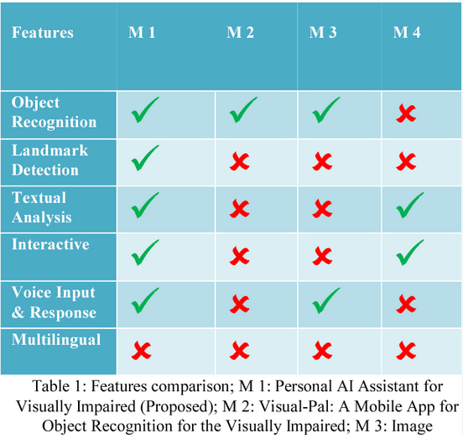

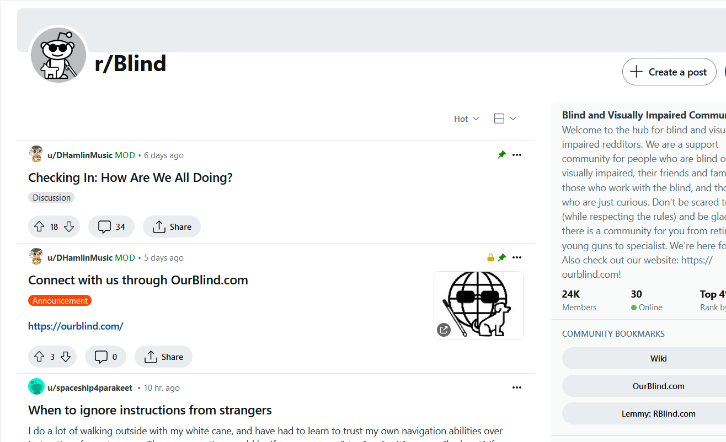

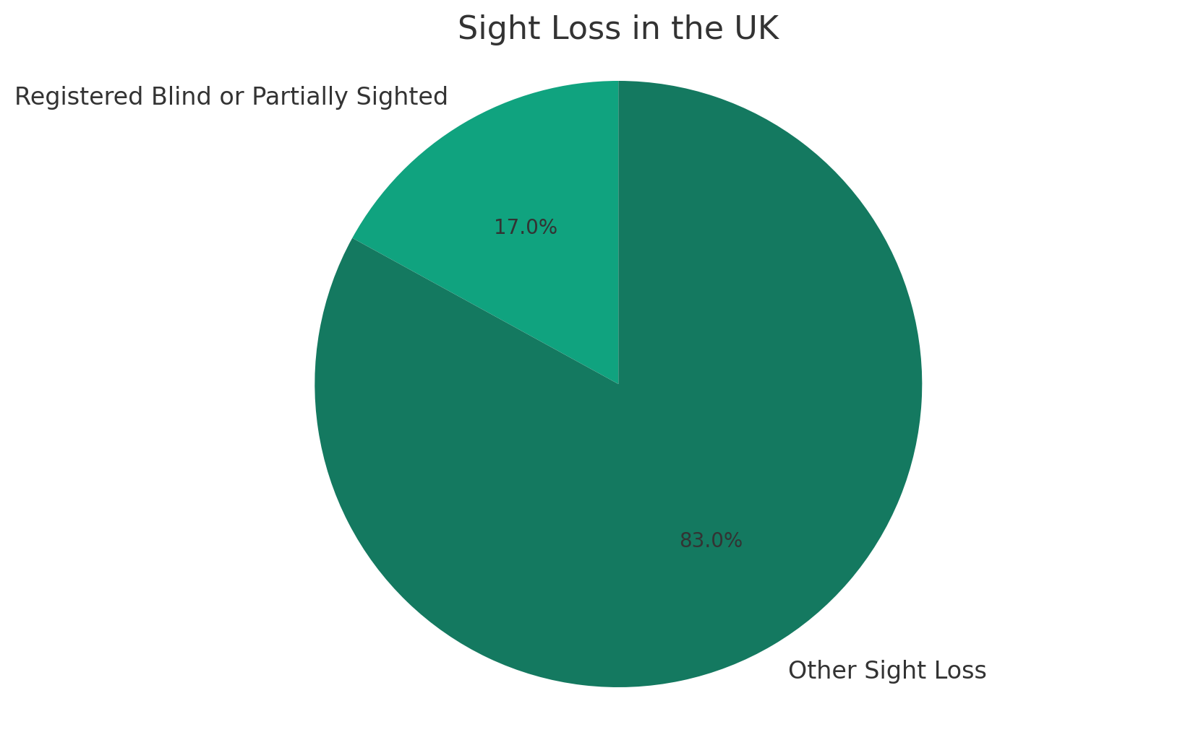

# Approach to Addressing Requirements

## 4.1 Brief Explanation of Strategies to Meet User Requirements

Brief Explanation of Strategies to Meet User Requirements:

* **Heuristic Evaluation:** To guarantee usability and accessibility for visually challenged users, a heuristic analysis of the stick and app interfaces is conducted.
* **Customization Options:** Creating customizable settings to cater to Indvidual preferences.
* **Public Transit System Integration**: Collaborating with transport for London transit authorities for real time integration into the app.
* **User Centric Design:** Focusing on an intuitive design for both the stick and the application, making sure it is comfortable and easy to use.
* **Consistency in the interaction:** We will maintain consistent and predictable interactions throughout the app and stick functionalities.
* **Error prevention:** Designing an application to prevent errors and enhance safety for the visually impaired.

# Conclusion

Our Project is set to aid the travel experience of visually impaired commuters by integrating intuitive tools, real time user feedback and a user-friendly application interface. Moving forward, we have a commitment that involves developing and refining our future prototype, conducting extensive user testing and collaborating with the visually impaired community. This will ultimately enhance their independence and safety in commuting.

# Bibliography and References

* **Healthify** (2024). Be My Eyes App Review. [online] Available at: [Be My Eyes - Healthify](https://healthify.nz/apps/b/be-my-eyes-app/) [Accessed 27 Feb. 2024].
* **Speechify** (2024). TapTapSee App Review. [online] Available at: [TapTapSee Review](https://speechify.com/product-reviews/taptapsee/) [Accessed 28 Feb. 2024].
* **Intech.media** (2024). BlindSquare App Review. [online] Available at: [BlindSquare Review](https://intech.media/en/smartcities/app-review-blindsquare/) [Accessed 26 Feb. 2024].
* **Blind Resources** (2024). Microsoft's Seeing AI App Review. [online] Available at: [Seeing AI Review](https://blindresources.org/2019/07/17/microsofts-seeing-ai-app-review/) [Accessed 28 Feb. 2024].
* **Living Made Easy** (2024). BlindSquare Accessible Navigation App. [online] Available at: [BlindSquare Navigation App](https://livingmadeeasy.org.uk/product/blindsquare-accessible-navigation-app) [Accessed 22 Feb. 2024].
* **AbilityX** (2024). Top 9 Apps for Navigation for the Visually Impaired 2024. [online] Available at: [Top 9 Navigation Apps](https://abilityx.io/news/top-9-apps-for-navigation-apps-for-the-visually-impaired-2024/) [Accessed 21 Feb. 2024].
* **Healthify** (2024). Be My Eyes App Review. [online] Available at: [Be My Eyes - Healthify](https://healthify.nz/apps/b/be-my-eyes-app/) [Accessed 20 Feb. 2024].
* Government of the United Kingdom. (2023). Disability, Accessibility and Blue Badge Statistics: England 2022 to 2023. [online] GOV.UK. Available at: <https://www.gov.uk/government/statistics/disability-accessibility-and-blue-badge-statistics-2022-to-2023> [Accessed 20 Feb. 2024].

# Appendices

